In aid of Arthur Rank Hospice in Cambridge (Charity Registration No 283353) and East Anglia Children’s Hospice in Milton (Charity Registration No 1069284), we are doing the 3 Peaks Challenge on 25/26 July. The Challenge is to climb the 3 highest mountains in Scotland, England and Wales (Ben Nevis, Scafell Pike and Snowdon) in 24 hours, including driving between the three mountains – that’s 3,407 meters to climb and a 1,182 mile round trip in one weekend.

We are 18 employees from the Royal Mail in the Cambridge area, and we would like your support for these worthy causes.

More information can be obtained on our website at www.redpouches.org.uk. Thanks for your support.

Name | Address | Gift Aid | Amount pledged | Paid  Y/N

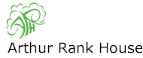 | 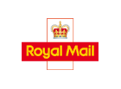 | 