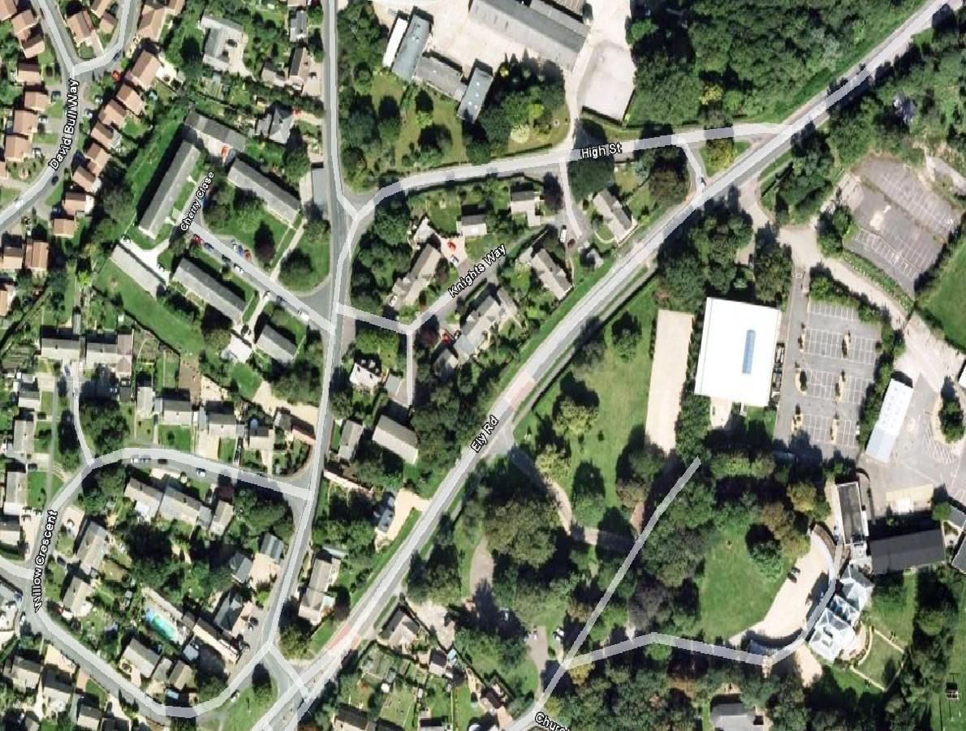
Entrance to Milton Hall from Ely Road, Milton

For SatNav coordinates, CB24 6WZ, although there will be plenty of signs and directions on the day
Towards Cambridge/Tesco Milton
Towards Ely/Waterbeach

